A Geospatial Activity
A Buffer from the Storms

In recent years, many hurricanes have made landfall in the United States, with the 2004 and 2005 hurricane seasons being particularly active. In 2004, five named storms made landfall in the United States. The storms caused over 3,132 deaths and $50 billion in damages. The next year, seven hurricanes made landfall in the United States causing over 2,280 deaths and $128 billion in damage. Most of the deaths and destruction in 2005 resulted from five of these storms: Dennis, Emily, Katrina, Rita, and Wilma. Hurricane Katrina and its 30-foot storm surge devastated southeast Louisiana while Wilma was the most powerful hurricane ever recorded in the Atlantic Basin.
Over half of the United States’ population lives within fifty miles of the coast and much of our coastline is being developed to support its growing population. In Louisiana, a complex network of levees and canals, built to protect New Orleans from being flooded by the Mississippi River, prevented silt from replenishing the coastal marshes. These same marshes would have partially protected New Orleans from Hurricane Katrina.
During a storm event, coastal marshes, wetlands, and barrier islands serve as the first line of defense against hurricanes. The vegetation and sediments can slow down the storm surge and absorb some of the storm’s energy and water, acting as a “buffer” from the storms. While sturdy vegetation, such as shrubs and cypress trees offer more protection than grasses against high winds, marsh grasses can absorb increased water levels. Removal of coastal vegetation removes the natural protection thee plants provide. Scientists estimate that for every square mile of wetlands lost in an area, storm surge rises by one foot.

Exploring Hurricanes along the East Coast
- Launch My World GIS. Open the project file name Hurricanes.m3vz. The project should open displaying the U.S. States and Countries layers.
- Turn on the Atlantic Hurricane Tracts 1851-2006 layer. To turn a layer on, click the Show/Hide Layer box located on the far right side of the layer’s control panel. When the layer is on, an eye, , will appear in the checkbox.
  - Use the , , and tools to explore the Atlantic Hurricane Tracts 1851-2006 layer.
Tip: If you zoom in too far, use the Zoom-to-the-Previous button or , the Zoom-to-All button.
Hurricanes are large tropical storms with heavy winds (greater than 74 mph). They generally begin in areas of warm moist air near the Equator. If atmospheric conditions are favorable and water temperatures are above 79 F, a storm will intensify and may become a hurricane.

Qn. 1. Describe the shape of most of the tracts. Where do they begin? Where do they end?
Qn. 2. How far west might the effects of Atlantic Coast hurricanes be felt?
- Explore the Atlantic Hurricane Tracts 1851-2006 data table.
  - First make the Atlantic Hurricane Tracts 1851-2006 layer active. To activate a layer, click anywhere on its control panel except the Show/Hide Layer box; when active, the panel will turn white with a yellow border.
  - Open the Atlantic Hurricane Tracts 1851-2006 data table by clicking, or by choosing Layer/Show Layer Table…. A message will appear telling you that this is a large data table and may take a while to open. Click OK, when asked if you still want to open the table.
  - Use the scroll bars to scroll across or down through the data table so you can see what categories of data it contains and what the data looks like.
  - Sort the data table by clicking on a column header. Try clicking WINDKTS (wind speed in knots), PRESSURE, or YEAR. On the first click, the data will be displayed in ascending order ; on the second click, it will be displayed in descending order ; and on the third-click, it will return to its original order.
Note: The sorting takes several seconds, so click only once and wait for the results.
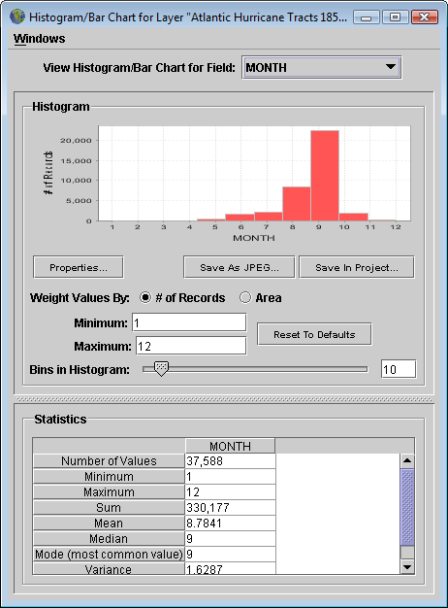
Qn. 3. What information is provided for each storm tract?
Qn. 4. Does each record represent a single hurricane? Explain.
  - Close the Table of Layer “Atlantic Hurricane Tracts 1851-2006” window.
- Create a histogram displaying the number of Atlantic Hurricane tracts by month.
  - Click to open the Histogram/Bar Chart window, and update it as shown on the right.
  - Choose the variable to be charted by using the View Histogram/Bar Chart for Field: pull-down window. Change it to: MONTH.
  - Make sure the Minimum: value is set to 1 (January) and the Maximum: value is set to 12 (December).
  - Set the number of Bins in Histogram: to 12.
  - Study the resulting histogram and the Statistics window.
Qn. 5. a) Which month has the most tropical cyclone activity (hurricanes, tropical storms, and tropical depressions)? b) Why do you think that is?
Qn. 6. According to your histogram, when is hurricane season? (Hint: Hurricane season is the period during which 97% of tropical storms occur .)

Tropical cyclones are organized, rotating systems of clouds and thunderstorms with a defined circulation pattern and are associated with low barometric pressure. In the Northern Hemisphere, the winds blow counterclockwise; in the Southern Hemisphere, they blow clockwise. As the wind speed increases, the classification changes from a tropical depression (winds up to 38 mph) to a tropical storm (winds between 39-73 mph) to a hurricane (winds greater than 74 mph). As the cyclone strengthens, the associated winds cause greater amounts of damage and storm surge. A Category 1 Hurricane causes minimal damage with wind speeds of 74-95 mph and a storm surge of 4-5 feet. A Category 5 Hurricane causes catastrophic damage with wind speeds of more than 155 mph and storm surges of greater than 18 feet. Category 3 Hurricanes and higher are considered to be major hurricanes.
- Change your histogram to display the records by CAT (Category). Use the scroll bar to move down to see the number of tropical depressions (TD) and tropical storms (TS).
Qn. 7. What does this histogram tell you about tropical cyclone activities? a) Compare the number of tropical storms and tropical depressions with the number of hurricanes. b) How does the number of Category 1 and 2 Hurricanes compare with the number of major hurricanes (Category 3 and higher)?
- Change your histogram to display the records by Pressure. Notice that a “0” is used as the null value; it indicates that no data exists about the air pressure inside a specific storm tract (as you can see, there are a large number of these.) Air pressure is measured in millibars.
  - Adjust the Minimum: and Maximum: values to focus on pressure differences between cyclones with recorded barometric pressures. Set the Minimum: value to 900 and the Maximum: value to 1050.
  - Use the slider bar to increase the number of Bins in Histogram. (Try sliding it to 100 the maximum number of bins allowed.)
  - Study the resulting histograms.
Qn. 8. Describe the pattern you see. Are powerful hurricanes associated with higher or lower air pressures?
  - Close the Histogram/Bar Chart window.
You can select only those records within a dataset that you are interested in. This technique is called querying.
- Query the Atlantic Hurricane Tracts 1851-2006 layer to select the records that are associated with Category 3 or higher hurricanes. Switch to Analyze mode, by clicking the Analyze tab above the Layer List. Choose: Select… by Value and update the window as shown on the next page.
  - Set Select Records from: to Atlantic Hurricane Tracts 1851-2006.
  - Set Whose: to CAT.
  - Click the check boxes after H3, H4, and H5.
  - Click the check box in front of Make Selection a New Layer.
  - After Result Name: type Atlantic Hurricanes Cat 3, 4, and 5.
  - Click OK.
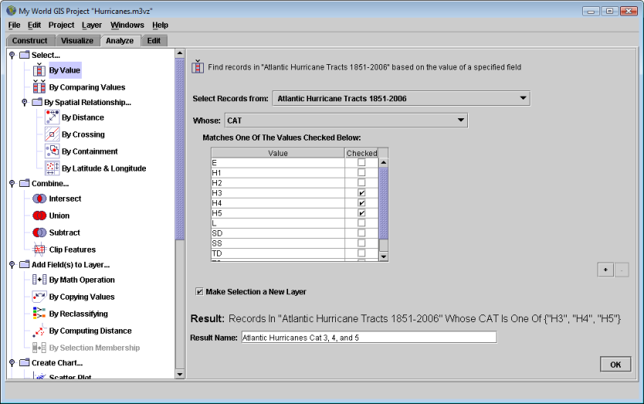
- Return to Visualize mode. Study the new layer showing Atlantic Hurricanes Cat 3, 4, and 5.
Qn. 9. How does the number of Category 3, 4, and 5 storms compare to the total number of storms?
Hint: Open the data table to see how many Category 3, 4, and 5 storms are selected.

Exploring Hurricanes in southern Florida
- Query the Atlantic Hurricane Tracts 1851-2006 layer to select hurricanes that made landfall in (crossed over) Florida.
  - Switch to Analyze Mode, and then choose: Select by Spatial Relationship… By Crossing.
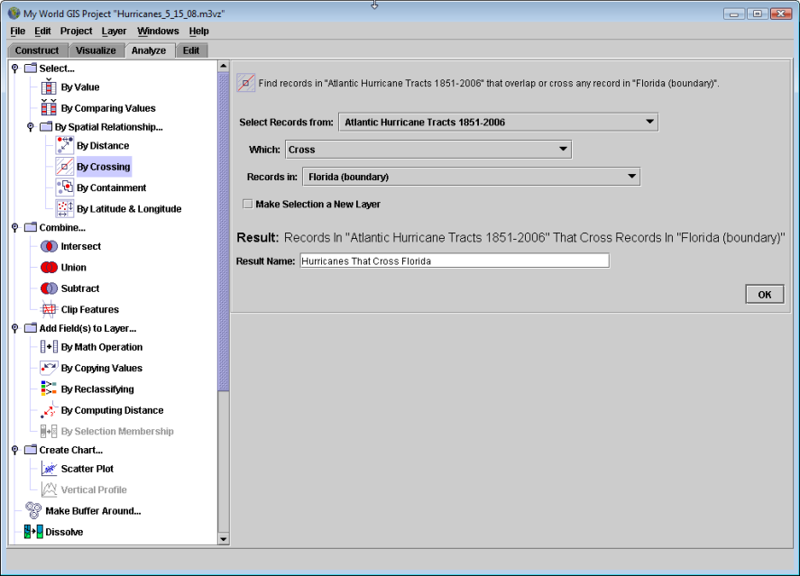
  - Update the Analyze window as shown below.
  - Be sure to set Select Records from: to Atlantic Hurricane Tracts 1851-2006.)
  - Select all records that cross Florida (boundary).
  - Name the layer Hurricanes that Cross Florida.
  - Click OK.

- Now perform a query on the Hurricanes that Crossed Florida layer. This time Select… by Value, and select the subset of records from CAT H3, H4, and H5 storms.
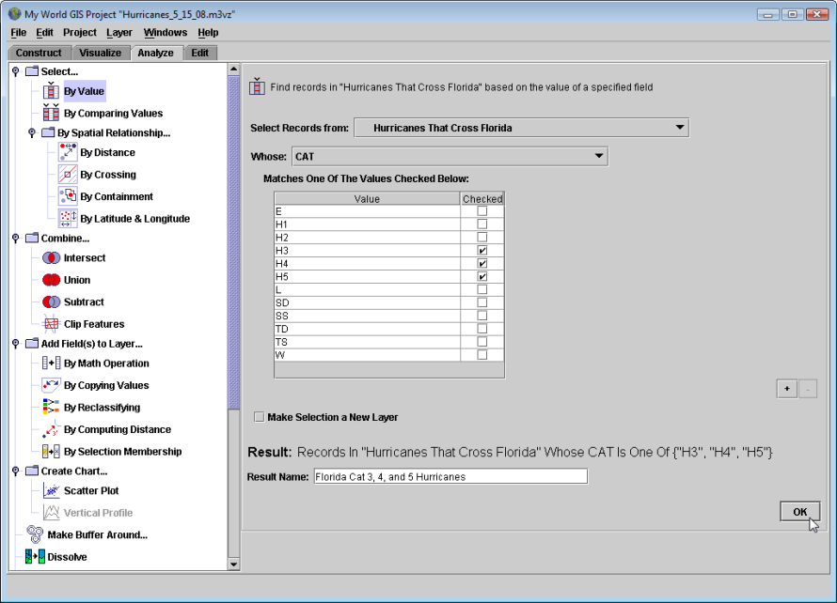
- Turn off the other hurricane layers (except for Florida Cat 3, 4, and 5 Hurricanes) and zoom in on Florida.
Qn. 10. In Florida, where do most of the Category 3, 4, and 5 hurricanes make landfall?
Qn. 11. a) How many Category 3, 4, and 5 hurricanes have made landfall in Florida? b) In what years did they hit? Hint: Open the layer table and count hurricanes. Be careful—some hurricanes are listed more than once. Check the names and/or dates of the storms to ensure you count each hurricane only once.

Hurricane Wilma (October 15-25, 2005)
Hurricane Wilma was one of the most intense hurricanes ever recorded in the Atlantic Basin. It developed as a tropical depression on October 15, 2005, and quickly intensified into a Category 5 hurricane. It made landfall several times: first on Mexico’s Yucatan Peninsula, next in Cuba, and finally in southern Florida. It then moved northward across the Atlantic Ocean before dissipating on October 25, 2005. At its peak, Hurricane Wilma had winds of 185 mph (300 km/hr) and an internal pressure of 882 mbar. Hurricane Wilma killed at least 63 people and caused $29.1 billion in damage, most of it in southern Florida. The Florida Keys were flooded twice during the storm, once as it crossed the state and again as water pushed into the Everglades by the storm retreated into Florida Bay. In recognition of the severity of the storm, the name Wilma has been retired from the list of storm names.

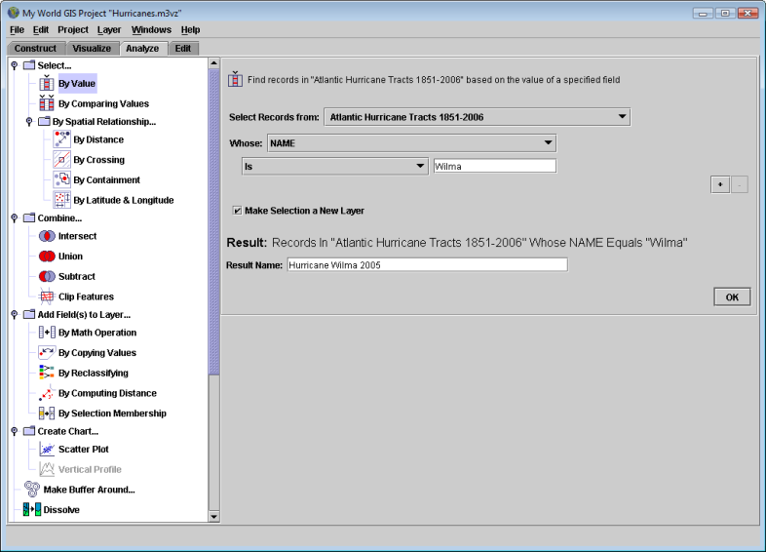
- Turn off Florida Cat 3, 4, and 5 Hurricanes layer.
- Query the Atlantic Hurricane Tracts 1851-2006 layer for Hurricane Wilma’s storm tract. Update the Select… By Value window as shown below. Make the selection a new layer named Hurricane Wilma 2005.

- Adjust the Hurricane Wilma 2005 legend so it displays storm strength (category). To do this, activate the Hurricane Wilma 2005 layer and open the Legend Editor clicking on the tool bar, or choosing Layer/Edit Layer Appearance.
  - Set the Choose Color by: window to CAT. Don’t worry about what Colorscheme: has been assigned to the categories—we’re going to change it to colors that indicate the severity of the storm.
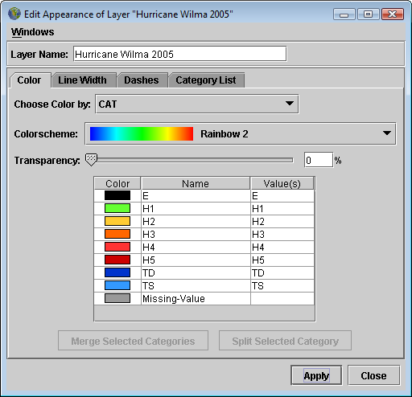
  - Double click on the colored symbols to the left of each category to open the Edit Value Color… window. Use the color picker to change the colors to those listed below and shown in the screenshot.
E: black
H1: light green
H2: yellow
H3: orange
H4: red
H5: dark red
TD: dark blue
TS: light blue
  - Click the Line Width tab and change the Line Width: to a thicker line.
  - Click Apply and then Close.
  - Study Hurricane Wilma’s tract. Use the tool to obtain information about specific segments of the storm tract, including wind speed (WINDKTS) and pressure.
Qn. 12. How strong was Hurricane Wilma before it made landfall in a) the Yucatán Peninsula, b) Cuba, and c) southern Florida? Note Wilma’s intensity (category), wind speed, and pressure, then complete the chart on your Data Sheet.
Strength of Hurricane Wilma Before Making Landfall
Location | Category | Wind Speed (knots) | Pressure (mbar)
Yucatan Peninsula
Cuba
Southern Florida

- Turn on the following layers: Everglades National Park, Canals – south Florida, Rivers – Florida (line), Rivers – Florida (polygon), Lakes – South Florida, and Counties -100 K – Florida and Population vs. Hurricane Strikes.
- Make the Population vs. Hurricane Strikes layer active and zoom in to it using either or, the Zoom to Active Layer tool.
- Pick a county in southern Florida that lies along the tract of Hurricane Wilma and explore the graph that has been linked to it.
  - Click, the Link tool. Flags will appear on the square red symbols in each county. With the tip of the cursor (the pointer finger), click on the center of the symbol in the county you picked.
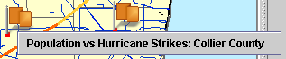
  - The name of the image linked to that symbol will appear below the flag. Click on the image’s name to open the linked graph.
A graph will open that shows the population by decade, and the number of tropical storms/hurricanes that impacted the county, what category each storm was, and whether the storm entered into or exited through the county. (Image Source: NOAA Coastal Service Center, Coastal Population Tool, http://maps.csc.noaa.gov/hurricanes/download.jsp).
Qn. 13. a) What county did you pick? b) Describe how the county’s population changed from 1900 to the present and the impact of hurricanes on your county. c) Describe the impact of hurricanes on your county. Include the following information in your description: How many storms impacted your county? What was/were the strongest storm(s)? When did it/they occur? Did your county receive any indirect hits from hurricanes? How does the population of the county affect the amount of damage?
- Turn off the Population vs. Hurricane Strikes layer.

Hurricane Wilma’s Impact on the Florida Everglades
As Hurricane Wilma passed across Florida, it left millions of people without electricity, blew roofs off buildings, and left neighborhoods filled with debris. It also impacted the natural environment. Heavy rains and winds stirred up bottom sediments in Lake Okeechobee and the Southern Florida Water Management District (SFWMD)’s Storm Water Treatment Areas. The Storm Water Treatment Areas are man-made, wetlands and containment areas that remove excess nutrients from surface waters. Nutrients that had accumulated for decades from storm water runoff entered into the Storm Water Treatment Areas and the Everglades. Along the southwest coast of Florida, mangrove forests faced the brunt of the storm. Trees were down, the canopy defoliated, and salt water was pushed far up the Shark River Slough and Taylor Slough watersheds.
- Display the Hurricane Wilma Images layer. Use the tool to explore images of damage caused by Hurricane Wilma.
Qn. 14. Describe the impacts of Hurricane Wilma on the Everglades that you observed in the images.
- Display the SRS TN TP Salinity, TS/Ph 6a – 7a TN TP Salinity, Taylor Slough and Shark River Slough layers.
Sampling stations at the Florida Coastal Everglades (FCE) Long Term Ecological Reserve (LTER) sites automatically sample and record water quality every 3-6 days depending upon the site and when it was established. The stations record the salinity, total nitrogen (TN) and total phosphate (TP) levels. The SRS TN TP Salinity layer includes water quality data from FCE LTER sites SRS 1 through SRS 6 located along the Shark River Slough watershed, while the TS/Ph 6a-7a TN TP Salinity layer has water quality data from FCE LTER sites TS/Ph 6a and TS/Ph 7a located along the Taylor Slough/PanHandle watershed.
- Activate the SRS TN TP Salinity layer.
- Open the SRS TN TP Salinity data table by clicking, the Show Table of Active Layer button. Determine the temporal coverage of the dataset – when did it begin? When does it end?
  - Sort the records in chronological order by clicking once on the top of the Date column. A symbol will appear after the column heading. Click again to sort the data in reverse chronological order (most recent first) , and again to return to the original order.
  - Use the scroll bar to move up and down the table if necessary.
- Query the SRS TN TP Salinity layer to determine the impacts of Hurricane Wilma on the water quality within the Everglades. Select the records by date to include from October 1, 2005 - November 30, 2005. (Hurricane Wilma made landfall on October 25, 2005.)
  - Switch to Analyze mode.
  - Choose Select…By Value and update the window as shown below.
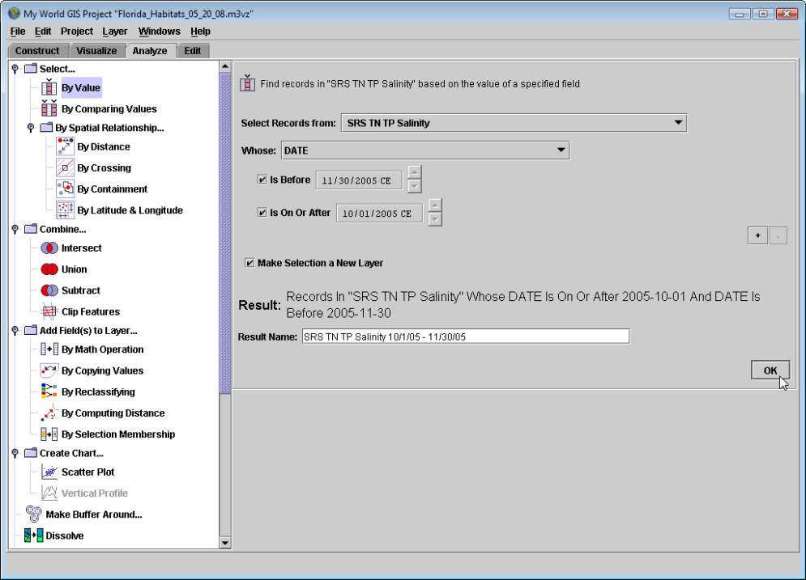

- Switch back to Visualize Mode and open the SRS TN TP Salinity 10/1/05 – 11/30/05 data table. Study the salinity levels at each site before, during and after Hurricane Wilma passed through the area.
  - Make SRS TN TP Salinity 10/1/05 – 11/30/05 the active layer.
  - Click , the Show Table of the Active Layer button.
  - Scroll through the table. Study the salinity level for each site. Record the values just before Hurricane Wilma, immediately after Wilma, and a few days later on your Data Sheet.
Qn. 15 Record the salinity values for each of the sites on the dates given in the table on your Data Sheet.
FCE LTER Station | 10/23 or 10/24 | 10/26 or 10/27 | 10/29 or 10/30 | Average
SRS 1c
SRS 2
SRS 3
SRS 4
SRS 5
SRS 6
TS/Ph6a (optional)
TS/Ph 7a
(optional)

Qn. 16. a) Which sites show a change in salinity as a result of Hurricane Wilma? b) Why did the salinity increase at these sites? c) At which site was no data recorded?
  - Close the Table of Active Layer “SRS TN TP Salinity 10/1/05 – 11/30/05” window.
- Determine the average salinity for each FCE LTER monitoring site along Shark River Slough.
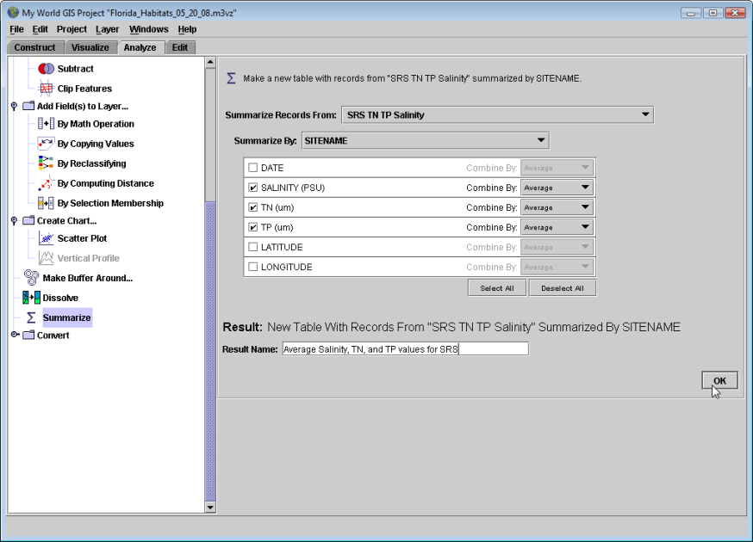
  - Switch to Analyze Mode.
  - Choose Summarize from the list on the right side of the window.

  - Set Summarize Records From: to SRS TN TP Salinity.
  - Set Summarize by: to SITENAME.
  - Choose SALINITY (PSU), TN (um), and TP (um) and choose Combine by: Average for each.
  - Name the table Average Salinity, TN and TP values for SRS.
  - Click OK.
Qn. 17. a) Record the average salinity value for each site in your Data Table for Qn. 15. b) How do the values you recorded compare to the long-term average values for each site? c ) Why is important to study an ecosystem for a long period of time?
To fully understand the spatial and temporal extent of the saltwater intrusion into the Everglades caused by storms such as Wilma, scientists would need water quality data sampled hourly at many more locations along the study transect. Marine sediment deposits have been found at some of the sample sites. Scientists rely on modeling to complement field datasets.
- If time permits, repeat the above analyses to look at changes in salinity along the Taylor Slough/Pan Handle sites, TS/Ph6a and TS/Ph7a. Activate the TS/Ph 6a-7a TN TP Salinity and use the techniques described above to determine salinity before, during and after Hurricane Wilma as well as the average salinity.
Scientists from many organizations, including the FCE LTER site, Everglades National Park and the Southern Florida Water Management District continue to monitor the water quality within the Everglades to determine the impact of natural variation and major storm events on the ecosystem. As fresh water flow through the Everglades system is reduced and salt water is pushed further into estuary system by major storm events, the boundary between freshwater marshes and mangroves slowly moves inland. The introduction of nutrients, such as phosphates and nitrates from either sea water or storm water run-off, affects the plant and microbial communities. The decomposition of organic material (e.g., plant material) is limited in the freshwater marshes and saw grass communities by a lack of phosphorus. The microbial communities need both oxygen and phosphorus to decompose dead plant material and to release the nutrients back into the ecosystem.
Qn. 18. What variables could you look at if you wanted to see what impact freshwater overflow resulting from Hurricane Wilma and its associated rainfall had on the ecosystem?
- Close My World GIS. When asked to save changes to the project, click No.

Further Explorations:
- Current hurricane tracts can be obtained from the National Hurricane Center; instructions for using their data sets in a GIS are available online: http://www.nhc.noaa.gov/aboutgisproducts.shtml.
- Additional datasets are available on the Florida Coastal Everglades LTER site Web page: http://fce.lternet.edu/ .

Resources:
- FEMA for Kids—Hurricanes: http://www.fema.gov/kids/hurr.html
- Journey to El Yunque: http://elyunque.net/english/introduction/hurricane.html
- National Hurricane Center: http://www.nhc.noaa.gov/
- NOAA Hurricane Portal: http://hurricanes.noaa.gov/
- Saffir-Simpson Hurricane Scale: http://www.nyc.gov/html/oem/html/hazards/storms_saffirsimpson.shtml and http://www.nhc.noaa.gov/aboutsshs.shtml
- Southern Florida Water Management District : After Hurricane Wilma https://my.sfwmd.gov/portal/page?_pageid=2814,19613308,2814_19613546&_dad=portal&_schema=PORTAL

