A Geospatial Activity
Name

Date

Period
Intro to Google Earth

- Go to www.google.earth.com
- Skim the tutorial on how to navigate the program:
http://earth.google.com/userguide/v4/tutorials/navigating.html
- Locate the Search pane on your left hand side and pick the tab "Fly to."
- Enter the town of your birth, the zip code and the country (if outside of the US). You will now "fly" to your birthplace.

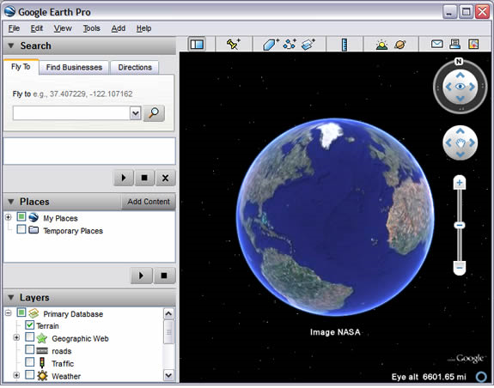

- Look up useful information that can be found at the bottom of the screen, then enter the following data about yourself:

Birthplace (city/town)

State or Country: Elevation:

Coordinates: Latitude Longitude

Describe the landscape/setting of your birthplace.

- Look up your current residence. Enter your address (house number and your zip code) in the "Fly to" section.

Using the slider and the controls in the upper right-hand corner of your screen, take a look at your house by clicking on, and holding the eye symbol. Notice, you can tilt the view. Go to the Layers pane and check the box: Terrain.

Coordinates: Latitude Longitude

Elevation: When was your house “captured” in Google Earth?

- Choose two relatives or friends who were born in a location different from where you were born. They should also have birthplaces that are different from each other. "Fly" to their birthplaces.

Relative’s or Friend’s birthplace (city/town)

State or Country: Elevation:
Coordinates: Latitude Longitude
Describe the landscape/setting of your birthplace.

Relative’s or Friend’s birthplace (city/town)

State or Country: Elevation:

Coordinates: Latitude Longitude

Describe the landscape/setting of your birthplace.

- Use the ruler to measure distances.
    - While still at your relative’s/friend’s birthplace, locate the ruler symbol at the top of your Google Earth map. Click on it.
    - Uncheck the box "Mouse Navigation".
    - Click on your relative’s/friend’s birthplace, then travel back to your own birthplace.
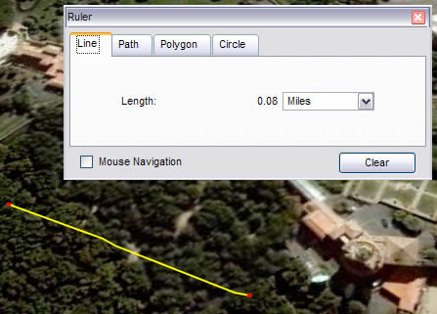
A line will appear on the globe.

What is the distance between their birthplace and your birthplace?

miles

kilometers

