A Geospatial Activity
Introduction to My World GIS

Background Information

There are situations where people want information. There are also situations where people want to know the location of where the information came from. For example, during flu season, health officials want to know how many people have the flu at different locations so they can track the spread of the flu. Linking information with a location can lead to a better understanding of the information and allows for some interesting relationships between data to be determined. Information (data) along with its location (space) is called geospatial data.

Computers can be used to plot geospatial data on maps. A computer program that plots geospatial data on a map is called a geographic information system (GIS). There are many types of GIS.

You will learn to use a simplified GIS program to create geospatial projects. The name of the GIS program you will learn is My World GIS. For the remainder of this lesson, My World GIS will just be called “GIS.”

Goal of Activity

In this activity you will learn the following basic GIS components and procedures:
- How to start GIS
- The layout of GIS
- How to start a Project
- How to find, open and utilize data files
- The basic methods of viewing maps
- How to add layers to maps
- How to change

How to Start My World GIS

- Launch My World GIS by selecting Start > All Programs > My World GIS > My World GIS 4.1, or by double-clicking the My World GIS icon on the desktop.
- Close the About Window when it pops up.
- Notice – a Welcome to My World information window pops up. You can always use this to get quick and simple information about My World GIS. For now, close the window.

Getting to Know the My World GIS Layout

Below is a view of the GIS window:
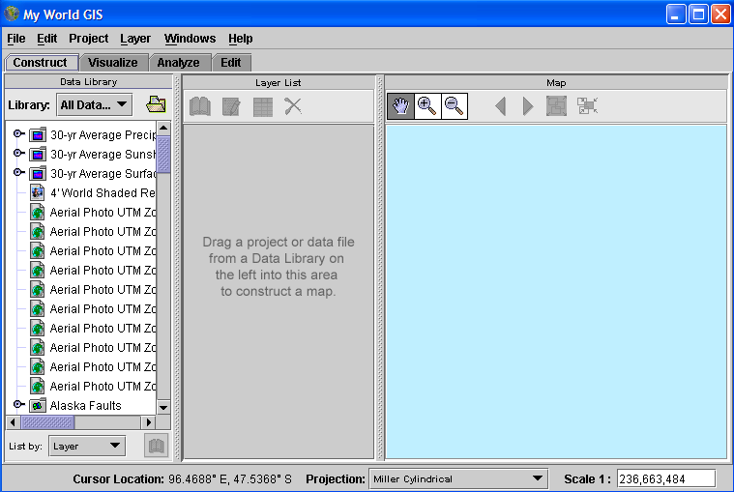

Menu Bar.
The GIS menu bar has the following selections: File, Edit, Project, Layer, Windows, Help.
You will learn more about each menu selection within this and future lessons.

GIS Mode Tabs.
Below the Menu Bar are four tabs. Each tab corresponds to a different mode: Construct, Visualize, Analyze, Edit.

GIS Sections (Panels).
Below the tabs are three sections: Data Library, Layer List, Map.
Data Library – this is a list of all the sets of data that are available. More sets of data can be added.
Layer List - this panel allows you to see which layers of data you are using for your project. You will learn more about “layers” later in this lesson.
Map – this is where you can see the map and layered data of your project.

Map Data
At the bottom of the GIS window is information regarding the longitude and latitude of the cursor, the type of map projection being used, and the scale of the map.

Creating a Project

You will learn the basics of GIS by creating a project. With this project you will create a map of the world, the states in the United States,

Identify the Data Files you will want to use for the project.
- Choose All Data Files from the Library dropdown menu in the Data Library. This allows you to see all the GIS data files currently available on your computer.
Add Data to the Layer List.
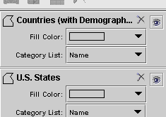
- Click the Countries (with Demographic Trends) file, then drag it to the Layer List. This action does two things. First, it creates a bottom layer of data on which you will add more data. It is the foundation of the project. Second, it starts to build a project map in the Map section. Each time you add a layer in the Layer List, the data is automatically added to the map.
- Click the U.S. States file, then drag it to the Layer List. Depending on where you drag the file in the Layer List, the U.S. States layer may be above or below the Countries layer. For now it does not matter. Latter you will see what the difference is and how to change the layer sequences, if necessary.
- Add the Major Highways, U.S. Cities, Continents and World Cities to your project. For now, do not worry about their sequence in the Layer List. The map now shows lots of lines in the U.S., and lots of red marks, each indicating a city.
- Delete the Continents layer by clicking on the X next to the Continent name. A window will pop up asking you to confirm that you really want to remove the layer – click OK.

We will continue working with your project, but let’s stop for a moment and learn more about GIS layers.

Understanding Data Layers

GIS works with data in layers, each on top or below another layer.

Sometimes one layer may cover up the data from another layer. If this happens, you will need to move the layer that was covered up to a higher position in the Layer List. To do this, click the title of the layer, then drag it up to the position you want it to be in the Layer List. When you let go, the data layer will be in the new position and you should then be able to see the data on the map. If you still can’t see it, you may need to move around a few of the other layers.

Generally, you want the outline of land as the bottom layer, and detailed data layers on top.

Using the Map Section

The GIS map can be modified. To modify the Map you will need to change to the Visualize mode.

Change to the Visualize Mode.
- Click on the Visualize tab. Remember, the four tabs are in the row beneath the Menu Bar. The Data Library section will be gone, but the Map section will have a column on the right with a list of data that is included on the Map. There is also a tool bar above the map.
- Move the Map around by clicking on the Move Map tool , then dragging the map. See what happens.
- Re-center the map by clicking on the Zoom to All tool .
- Zoom in to an area of the map by selecting the Zoom In tool, then clicking on a location on the map. The more you keep clicking, the more you zoom.
- Zoom out of an area by selecting the Zoom Out tool then clicking on a location on the map. As with the Zoom In tool, the more you click, the more you zoom out.
- Zoom in to a region by selecting the Zoom In tool, then dragging a box around the region. When you let go of the mouse, the region will zoom in.
- Go back to a previous view by clicking the Zoom To Previous Extents tool .

Faster way to Zoom
- Click on the title U.S. States in the Layer List, then click the Zoom to Selection tool. You will automatically zoom into the U.S. Zoom further into Florida by using the Zoom In tool as described in step #9.

Finding Information

Remember that each layer that makes up the map was really data from the Data Library. That means that each layer is made up of a collection points, lines or polygons defined by the data. Depending on the data library, each layer can contain information about natural features such as rivers and lakes, or man-made features such as roads and populations of cities.

Information about each feature such as its name and size, is located in an associated database called an Attribute Table. Attributes can be found using the Get Information Tool .

Using the Get Information Tool.
- Click the Major Highways layer to make it active. Choose the Get Information Tool, then click on a highway in Florida. A window will pop up with information about the highway.
Accessing the Attribute Table.
- With the Major Highways layer still active, click on the Show Table of the Active Layer tool, found at the top of the Layer List. This tool allows you to see all the information for an entire data layer.

Displaying Map Data

GIS allows users to view data in a way that is meaningful to them. Sometimes they may want to make a data layer invisible, and sometimes they may want to add or change colors of the data.

Turning a Layer Off
- Click the eye icon in the Major Highways layer to turn it off. When the eye is open, the layer is on, when the box that the eye is located in is empty, the layer is turned off. When a layer is off, it is not visible on the map.
- Click the box in the Major Highways layer to turn it back on. Notice the eye reappears.

Setting Colors
- Double-click the U.S. States layer in the Layer List. A window will pop up called Edit Appearance of Layer.
- Select the Fill Color tab.
- Click the Edit button and select a green color from the color palette and click OK. Click Apply at the bottom of the Edit Appearance of Layer window, then close the window.

Setting Colors by Value
- Again, Double-click the U.S. States layer in the Layer List. Select the Fill Color tab.
- Click the Edit button and click on the little down arrow at the end of the pulldown menu titled Choose Fill Color By. A selection of data criteria will appear.
- Select Population (2000). You will see a chart of the different colors assigned to areas of different populations.
- Click the down arrow at the end of the box titled ColorScheme and select a different set of colors that you like. Click Apply and close the window.

Explore GIS

Now that you see a little bit of what GIS can do, complete the first activity using the instructions above to guide you. Have fun!

