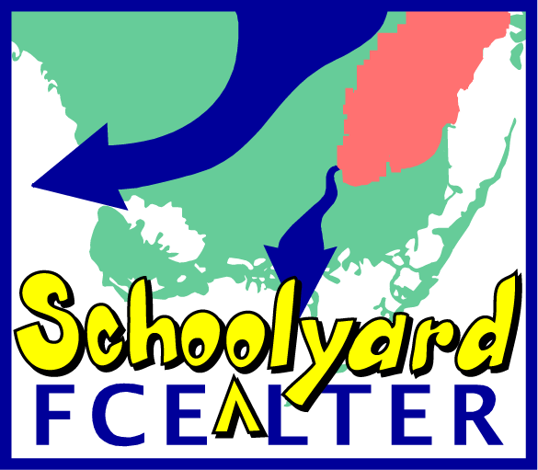
LTER Site Locations & Classification

DIRECTIONS: While viewing the LTER Introduction to Ecology presentation, record the latitude and longitude for each LTER site, classify them being within the polar, temperate or tropical zone and record the major biome each site represents.

Acronym LTER Latitude Longitude Zone Major Biome
LNO Network Office __________ __________ __________ ________________________
AND Andrews __________ __________ __________ ________________________
ARC Arctic __________ __________ __________ ________________________
BES Baltimore Ecosystem Study __________ __________ __________ ________________________
BNZ Bonanza Creek __________ __________ __________ ________________________
CCE California Current Ecosystem __________ __________ __________ ________________________
CDR Cedar Creek Natural History Area __________ __________ __________ ________________________
CAP Central Arizona - Phoenix Urban __________ __________ __________ ________________________
CWT Coweeta __________ __________ __________ ________________________
FCE Florida Coastal Everglades __________ __________ __________ ________________________
GCE Georgia Coastal Ecosystems __________ __________ __________ ________________________
HFR Harvard Forest __________ __________ __________ ________________________
HBR Hubbard Brook __________ __________ __________ ________________________
JRN Jornada Basin __________ __________ __________ ________________________
KBS Kellogg Biological Station __________ __________ __________ ________________________
KNZ Konza Prairie __________ __________ __________ ________________________
LUQ Luquillo __________ __________ __________ ________________________
MCM McMurdo Dry Valleys __________ __________ __________ ________________________
MCR Moorea Coral Reef __________ __________ __________ ________________________
NWT Niwot Ridge __________ __________ __________ ________________________
NTL North Temperate Lakes __________ __________ __________ ________________________
PAL Palmer Station __________ __________ __________ ________________________
PIE Plum Island Ecosystem __________ __________ __________ ________________________
SBC Santa Barbara Coastal __________ __________ __________ ________________________
SEV Sevilleta __________ __________ __________ ________________________
SGS Shortgrass Steppe __________ __________ __________ ________________________
VCR Virginia Coast Reserve __________ __________ __________ ________________________

